Robert E. Lee Soil & Water Conservation District
July 2021- June2022 Annual Report
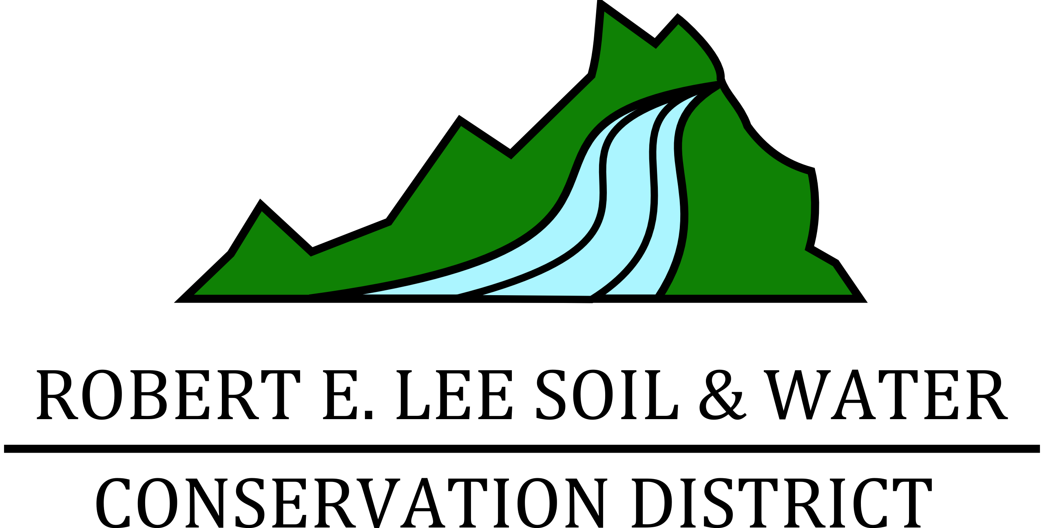

7631 A Richmond Highway
Appomattox, VA 24522

O: (434) 352-2819
F: (434) 352-9405

www.releeconservation.com

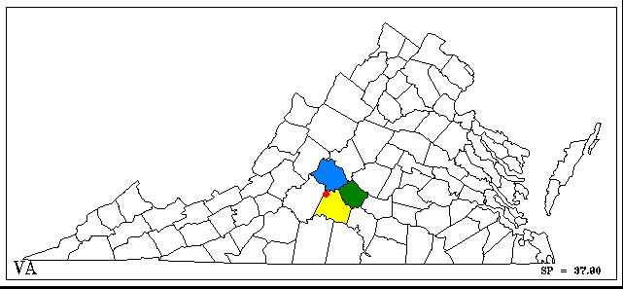
Serving the Counties of Amherst, Appomattox, Campbell and the City of Lynchburg.

The Board of Directors meets the fourth Thursday of each month at the Spring House Restaurant at 6:00 pm. The meeting facility is accessible to persons with disabilities. All meetings are open to the public. Please call to confirm in case of cancellation or location change.

“ The Commonwealth of Virginia supports the Robert E. Lee Soil and Water Conservation District through financial and adminstrative assistance provided by the Department of Conservation and Recreation.”

All programs and services of the Robert E. Lee Soil and Water Conservation District are offered on a non-discriminatory basis without regard to race, color, national origin, religion, sex, marital status or handicap.

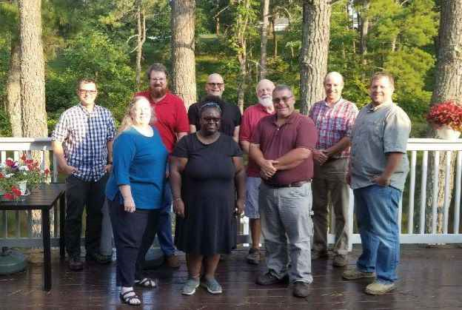
TheRobert E. Lee Soil & Water Conservation District serves the Counties of Amherst, Appomattox, Campbell and the City of Lynchburg which covers an area of about 1385 square miles. Programs and initiatives are directed by a Board of Directors. Two Directors from each of the three counties and the City of Lynchburg are elected to four-year terms in the regular general elections. Two additional Directors are appointed; one serves as a Director at-large and the other represents the Virginia Cooperative Extension. Associate Directors can also be appointed by the Board.The long range responsibilities of Soil and Water Conservation Districts are to provide technical assistance, educational resource and cost-share funding to producers and landowners to install conservation practices that reduce soil erosion and prevent non-point source pollution from entering our water resources. The staff is responsible for the following: Administration of the Virginia Cost-Share Program and the Falling River TMDL Cost Share Program, operate and maintain six watershed dams for flood control in Appomattox and Campbell Counties, coordination of watershed surveys and monitoring in the Amherst protected watersheds, conservation education and outreach, grant oversight for special watershed initiatives and coordination of District operations.
The mission of the Robert E. Lee Soil and Water Conservation District is to be a leader in natural resource conservation through partnerships, conservation education and technical assistance.

Welcome to Lauran Campbell our new Education Conservation Specialist

Directors

Jeff Floyd, Chairman
Brandon Schmitt, Vice Chairman
Bruce Jones
Bonnie Swanson
Chad Barrett
Doug Perrow
Brandon Payne
Charles Smith
Joetricia Humbles
Karen Angulo

Staff

Cindy Miller: Office Administrator

Jonathan Wooldridge:Ag. BMP Conservation Specialists

Lauran Campbell: Conservation Education Specialist

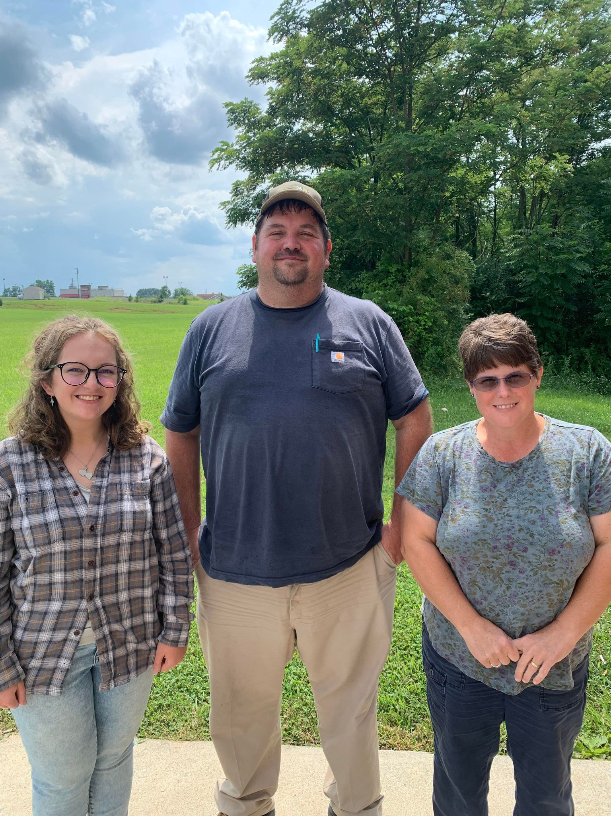
7631-A Richmond Hwy.
Appomattox, VA 24522
www.releeconservation.com
Office (434)352-2819
Fax (434) 352-9405
The Board of Directors meets on the fourth Thursday of each month at the Spring House Restaurant at 6:00 pm.Meeting facility is accessible to persons with disabilities. Meetings are open to the public. Please call to confirm in case of cancellation or location change.

Financial Report
Robert E. Lee Soil and Water Conservation District
Financial Report for Fiscal Year
July 1, 2021- June 30, 2022
Allocations

Department of Conservation/Recreation
Administrative Operations $197,675
Agricultural Tech Assistance $229,225
Dam Maintenance $18,000
$444,900

Department of Conservation/Recreation
Chesapeake Bay VACS $1,338,379
Outside Chesapeake Bay VACS $532,611
Total: $1,870,990

Local Sources
Amherst County $8,500
Appomattox County $10,000
Campbell County $10,000
City of Lynchburg $10,000
$38,500
Total: $2,354,390

Expenses

Administrative Operational $34,089,668
Virginia Agricultural Best Management FY2022
Practices cost share paid to agricultural Producers
CBVACS $65,807,929
OCBVACS $ 83,336,555
Total $149,144,494

2021-2022 Virginia Agricultural BMP Cost Shares

The Robert E. Lee Soil and Water Conservation District obligated $1,875,732.00 in the Program Year 2022 to agriculture producers and non-industrial private forest landowners. District cost-share funding provided financial assistance for: livestock stream exclusion fencing, cover crop, nutrient management, livestock waste storage and afforestation of hay, crop and pastureland. The district had 16 contracts in the Outside Chesapeake Bay Basin and 19 in the Chesapeake Bay Basin. The District had a good mix of livestock exclusion, cover crop, continuous no-till, continuous livestock exclusion maintenance, long term conversion of cropland to grass and livestock waste structure practices.

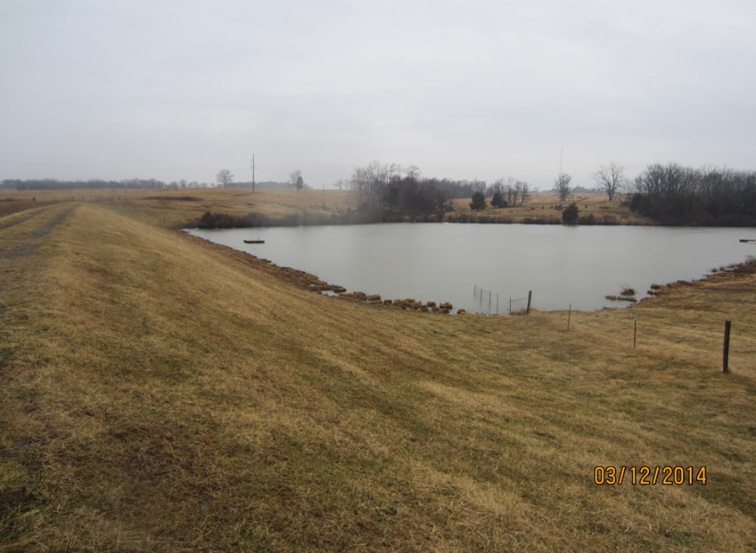
Watershed Dams

The Robert E. Lee Soil and Water Conservation District oversees the operation and maintenance of six watershed dams. Three watershed dams are located along the East Fork Falling River in Appomattox County. In Campbell County the three watershed dams are located along the Little Falling River. These impoundments provide flood control for large rain events. The District keeps a routine schedule on checking the watershed dams including when extra trips are required due to large rain events. All six watershed dams are mowed and brush cut twice a year which has helped with the control of brush and weeds. Each watershed dam’s EAP has been updated and inspected.

District 2021 Clean Water Farm Award

Kinkle Robinson owners of Laithreach Farms were the recipients of the 2021 Clean Water Farm Award. Laithreach Farm is a family-owned beef cattle operation in Pamplin, VA. Their property consists of 1300 acres with 550 being in pasture and the rest divided between planted pines and hardwood timber. They run 150 Angus brood cows in a rotational grazing system. “Thanks to the help provided by RELSWCD we no longer have cattle in the creeks on our farms. RELSWCD helped us strategically install cattle waters to work within a created grazing paddock design. Our grazing management plan allows us to stockpile grass for fall grazing. The ability to stockpile has been a cost sav for our operation by eliminating any fall hay production. Additionally, our cattle to new pasture every few days. This increased interaction with the cattle only makes the cattle easier to handle. We are currently taking steps to improve the soil health of our pastures. We believe with better soil health; we will grow more and better grass which will lead to healthier and more productive cattle. Thanks to RELSWCD for all their help.”

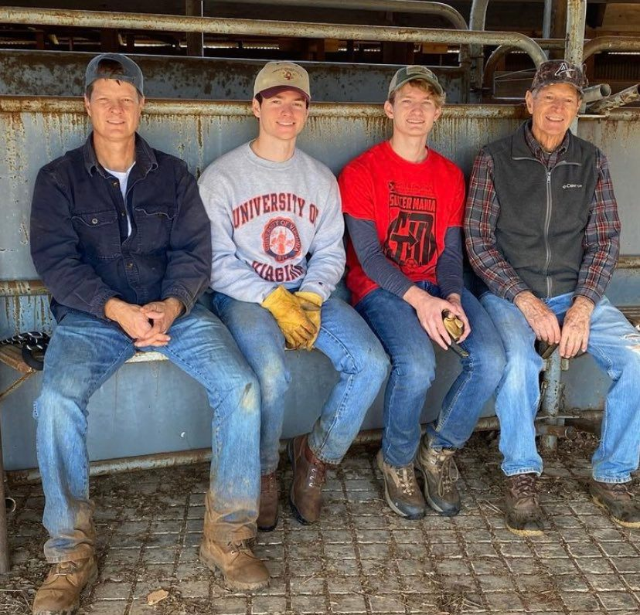

Pictured left to right is Kinckle Robinson, Kincaid Robinson, Parks Robinson and Richard Robinson.
Natural Resources Conservation Service
2021 Annual Summary

The Rustburg NRCS office has seen a lot of changes in the last year. The following employees retired: Don Yancey on May 31, 2021 and Ann Evans on December 31, 2021. Kelly Burke a NRCS employee with 18 years of experience in Wyoming, Washington, Montana, and Minnesota replaced Don Yancey as the Rustburg District Conservationist.
NRCS is actively working with established and new farmers and ranchers on several applications under the Farm Bill Programs. Current programs include Environmental Quality Incentive Program (EQIP), Conservation Stewardship Program (CSP) Classic and Renewals and the new EQIP – Conservation Incentive Contract (CIC). In addition, EQIP Conservation Activity Plans (CAP) plans have been reorganize into three new categories—Conservation Planning Activities (CPAs), Design and Implementation Activities (DIAs), and Conservation Evaluation and Monitoring Activities (CEMAs).
Not all of our applicants can be approved for contracts due to state allocation funding. However, we have continued to work with them giving technical assistance and land management guidance as needed.
Our mission statement is “We deliver conservation solutions so agricultural producers can protect natural resources and feed a growing world”. It takes a cooperative effort with all of our conservation partners and other natural resources management agencies to pursue this mission.
For more information on NRCS visit the website: www.nrcs.usda.gov or NRCS can be contacted by calling 434-332-6640 ext 3, for the Rustburg, VA office. Kelly Burke and Lauren Cheatham are willing and able to work with all our local producers.
USDA is an equal opportunity provider, employer, and lender.

Date | Subject | Location | #’ Reached
12/13/2021 | Rain Garden in a Cup | Appomattox | 13
12/15/2021 | Read and Craft with Preschoolers | Appomattox | 8
12/17/2021 | Water Cycle | Campbell Co. | 45
1/1/2022 | Wetland Hike | JRSP | 7
1/5/2022 | Enviroscape | Campbell Co | 13
1/12/2022 | Read and Craft with Preschoolers | Appomattox | 7
2/3/2022 | Tabling for Scholarship | Appomattox | 30
2/5/2022 | Road Clean up | Appomattox | 10
2/10/2022 | Dirt on Gardens | City of Lynch | 7
2/22/2022 | Trivia Tuesday | Virtual | 25
2/23/2022 | Soil Studies | Appomattox | 17
1/28-2/14/2022 | Recycled Valentines | Office (kits) | 80
3/9-3/10/2022 | Thunderstorm in a bag/Snowstorm in a Cup | Appomattox | 63
3/11/2022 | Science Fair Judge | Appomattox | 80
3/16/2022 | Water Quality | Campbell Co | 21
3/22/2022 | Yellow Branch Elem. Enviroscape | Campbell Co | 60
3/24/2022 | Envirothon Workshop | Longwood | 80
3/29/2022-4/1/2022 | Appomattox Elementary School Enviroscape | Appomattox | 143
4/6/2022 | Read and Craft Preschooler | Appomattox | 15
4/11/2022 | Erosion Activity | Appomattox | 11
4/12-4/14; 5/2/2022 | Water Quality | Campbell Co. | 88
4/16/2022 | Recycle Field Day | Appomattox | 26
4/20/2022 | Kindergarten Day @ACHS | Appomattox | 173
4/21-4/22/2022 | Trout in Classroom | Amherst | 98
4/26/2022 | Area V Envirothon | 4H Center | 80
5/4/2022 | Enviroscape/Rain Garden in a cup | Appomattox | 22
5/10/2022 | Water Quality | City of Lynch | 80
5/14/2022 | Pollinators | JRSP | 15
5/20/2022 | Enviroscape/ Water Quality Field Trip | JRSP w/ Appomattox | 18
5/25/2022 | Read and Craft with Preschoolers | Appomattox | 18
5/26/2022 | Soil Babies | Appomattox | 37
6/6/2022 | Enviroscape | Amherst | 40
6/8/2022 | Craft Day @ Appomattox Library | Appomattox | 150
6/20-6/25/2022 | Camp Woods and Wildlife | Appomattox | 62
 |  | TOTAL | 1,643
Conservation Education

This year we added a new Conservation Education Specialist. In November, we welcomed Lauran Campbell. We were able to reach close to 2000 people since November. Scholarships were provided to an Appomattox and Amherst County High School graduate to further their education. We look forward to what our next year holds for us. We hope to reach more people this year and spread the word on all that RELSWCD can help them with.

Field Trips

The District coordinated one field trip to James River State Park to learn about water quality for the Appomattox Christian Academy (18 students). These students were able to learn about nonpoint and point source pollution along with completing an activity with macroinvertebrates.
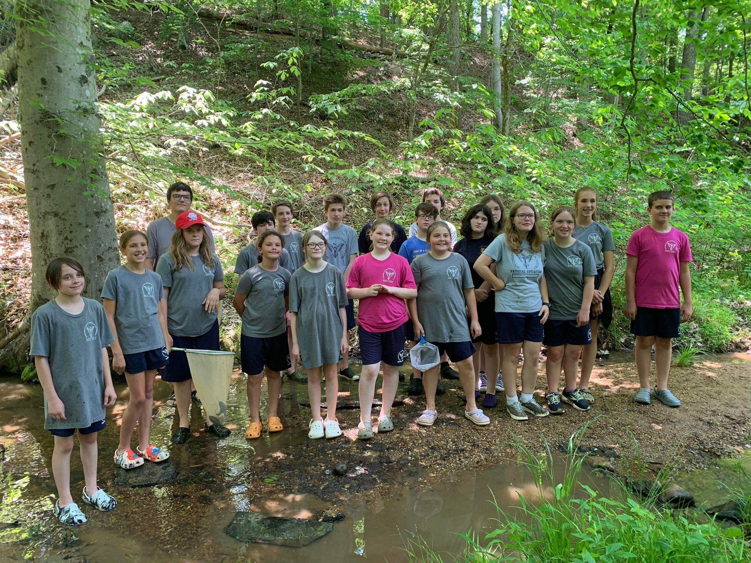

Camp Woods and Wildlife

The District sponsored a camper to the Camp Woods and Wildlife at Appomattox 4-H Center held June 20-24, 2022. Camp Woods and Wildlife is an academic, structured, residential camp that focuses on field experiences in forestry and other natural resources for 13–16-year-olds.
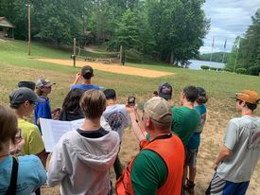

Trout in the Classroom

The Amherst Middle Schoolhosted a trout release and stream ecology field trip this year! The District and Trout Unlimited teamed up to teach students about trout fishing, trout habitat and food sources. The students enjoyed a day releasing trout they raised in the classroom and wading in the river learning about aquatic ecology and riparian buffers.

Educational Programs
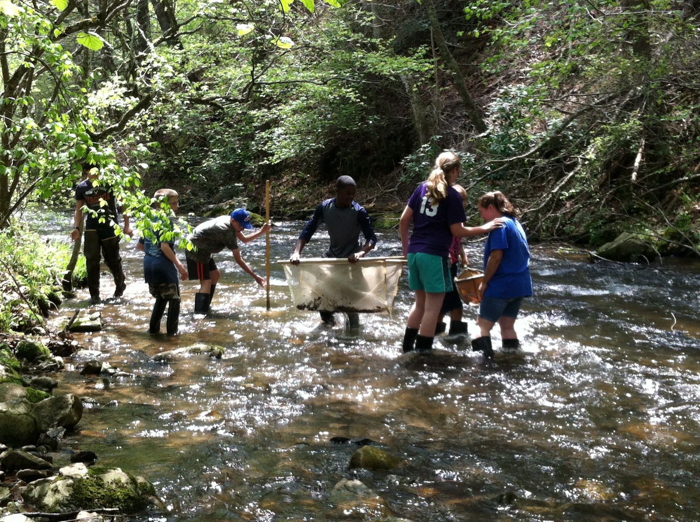

Forestry in Appomattox County-2021-2022

Forestry is an important business in Appomattox County. Two out of every five people are employed by the forest industry or related field. One and a half individuals with the Virginia Department of Forestry (V.D.O.F.) in Appomattox County manage approximately 155,000 acres of private forestland. Fifty-Two tracts for 2104 acres have been harvested this year in the County. Private Industry harvested 676 acres and thinned 304 acres. Total harvests for private landowners totaled 1124 acres. Reforestation consisted of 17 tracts for 699 acres of Loblolly Pine. There were 5 tracts of open land totaling 122 acres that were planted under the James River Watershed program. 399 acres of Loblolly pine was thinned to improve growth and volume of those stands this year. Approximately 425 acres was either left to regenerate naturally, developed or converted to agriculture. This can be a misconception as some of those tracts harvested were left so they can be site prepared and planted in 2022. In order to reestablish Shortleaf pine in its natural habitat approximately 1 acres has been planted this year. Longleaf pine is being promoted in the coastal areas while Shortleaf Pine is being reintroduced in the Piedmont area. Aerial release of Pine plantations from hardwood suppression totaled 4 tracts for 157 acres. Site Preparation totaled 9 tracts for 475 acres.

Wildfire is always a threat to our forest resources and to homeowners. Fragmentation creates a new fire hazard as homeowners continue to build homes in the forest. Woodland home protection plans are highly recommended by the V.D.O.F. and are available upon request. Twelve fires totaling 35 acres have occurred so far this year. Quick response by the fire department and forestry keeps these fires to a minimum size. Smokey Bear is the main fire prevention tool used by the Virginia Department of Forestry.

The V.D.O.F. is responsible for promoting fire safety throughout the county and the school system. A Fire prevention program is presented at the Primary School in which each student gets to meet Smokey Bear in person. This totals 22 classes of 650 students. The Department also participates in Little Farmer’s Day and conducts a Natural Resource Day in which the students learn about our Natural Resources. Due to the Covid 19 virus, our visit to the Primary school was canceled. Programs at higher- grade levels are available upon request. The Department works closely with the Forestry teams at the High School and Middle School. Training for teachers to use materials directly related to the Standards of Learning and Project Learning Tree to promote conservation and protection of our natural resources is available. Wildland Fire Training is available to anyone who is interested at our Fire Academy located at Longwood University each year.

Water Quality is a top priority in Appomattox County. The V.D.O.F. monitors all harvesting operations to assure there is an excellent voluntary program of Best Management Practices and no violations of the Water Quality Law. If a violation occurs, the V.D.O.F. is responsible for implementing procedures to see that the problem is resolved. There were no violations out of 52 inspections this year. Cost share practices are available to the loggers. Timber harvesters have taken advantage of incentive programs available for thinning small tracts. We should complement the loggers for their efforts in trying to do the best they can in keeping our water clean.

Finally, the Town of Appomattox is currently celebrating its tenth year of being a Tree City U.S.A. member.

The greatest asset that the Department of Forestry has is the great teamwork provided by the County, Town, S.W.C.D., Extension and N.R.C.S. in completion of various projects within the county and I thank them for that